Q-1 Consider the following two tables

Teacher:

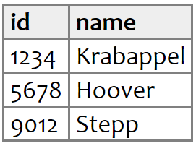

Course

|  |  |  |
| --- | --- | --- |
| Id | Coursename | Term |
| 1234 | DBMS | 21221 |
| 9012 | Computer Network | 21221 |

Implement the following queries:

1. Write a query to create table teacher with attributes id and name without any primary key
2. Write a query to create a table course with column id, coursename and term. Take a id column as a reference column from teacher table
3. Add a column sitting place in the teacher table
4. Write a query to add primary key on the id column of teacher table
5. Write a query to insert the values in the table as details are mentioned
6. Write a query to delete column term from course table
7. Write a query to change the length of the coursename column to 32